SHULL SCIENCE · JAMES A. GARFIELD LOCAL SCHOOLS
LIGHT FROM ELECTRON DROPS
OPTIONAL PRACTICE · ATOMIC & ELECTRON SPECTRA · TEACHER KEY
NAME | DATE | PERIOD

When an electron drops to a lower energy level, the atom gives off a photon. The bigger the drop, the more energy the photon carries. Use your notes from S2.5.

PART A · HYDROGEN'S VISIBLE LINES
1 On the energy ladder, draw an arrow for each drop: 3 → 2, 4 → 2, 5 → 2 and 6 → 2.
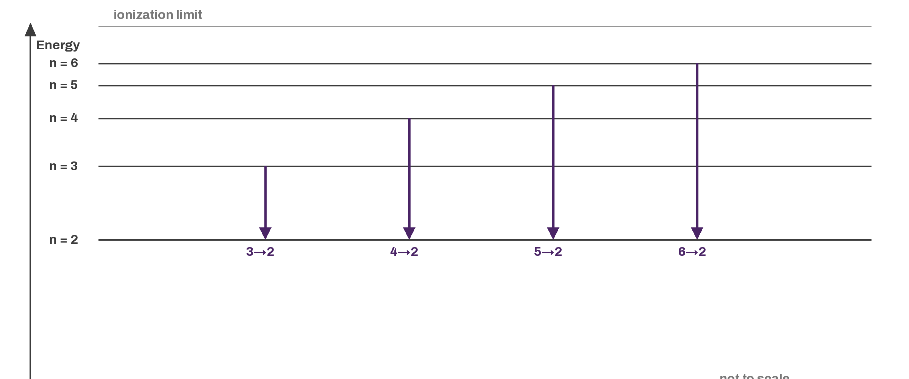
2 Fill in the wavelength and color of each line.

DROP | WAVELENGTH (nm) | COLOR
n = 3 → 2 | 656 | red
n = 4 → 2 | 486 | blue-green
n = 5 → 2 | 434 | blue-violet
n = 6 → 2 | 410 | violet
3 Rank the four drops from least energy to most energy.
3→2, 4→2, 5→2, 6→2

4 Use the ladder to explain why the 6 → 2 photon has the most energy and the shortest wavelength of the four.
It is the biggest gap, so the photon carries the most energy.

PART B · IN OR OUT

ELECTRON MOVES | ABSORBS OR EMITS | PHOTON IN OR OUT
n = 1 → 3 | absorbs | in
n = 4 → 2 | emits | out
n = 2 → 6 | absorbs | in
n = 5 → 1 | emits | out
6 Which drop gives off more energy, 3 → 1 or 3 → 2? Use the size of the gap in your answer.
3→1. It is a bigger gap than 3→2.

PART C · THREE KINDS OF SPECTRA

WHAT YOU SEE | KIND OF SPECTRUM
Every color, with no gaps | continuous
Bright colored lines on a dark background | emission
Dark lines across a full rainbow | absorption

PART D · FLAME TESTS

FLAME COLOR | ION IT POINTS TO
Yellow | Na+
Lilac | K+
Blue-green | Cu2+
9 Li⁺ and Sr²⁺ both give a red flame. Why is a flame color only a clue, not proof of which ion is there?
Different ions can give similar colors, so another test is needed.

